1] Create an account on firebase

2]After finishing with the signup part you will see this screen, simply click on “Go to console” button.

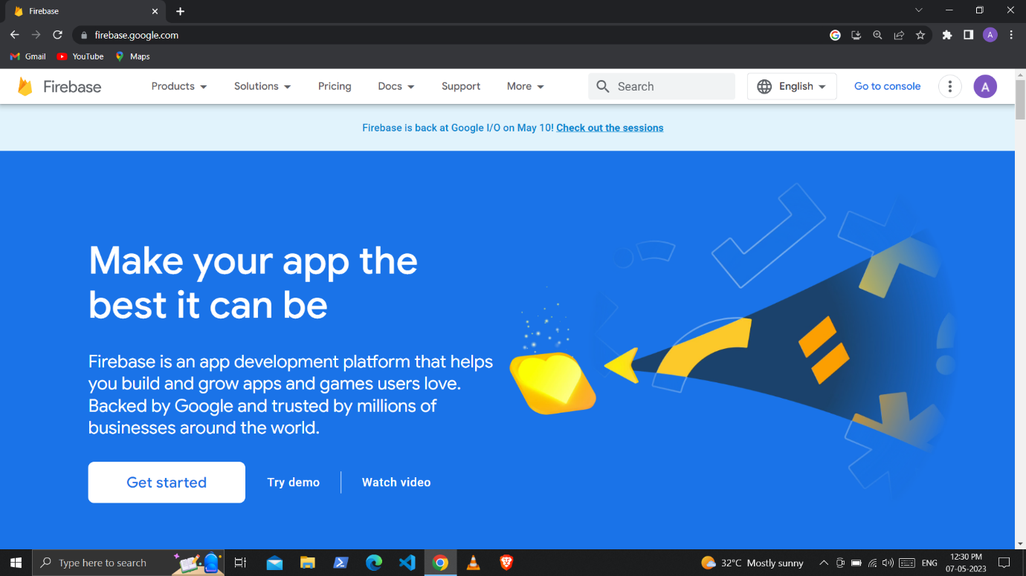  
3]There click on Add project component to add a new project

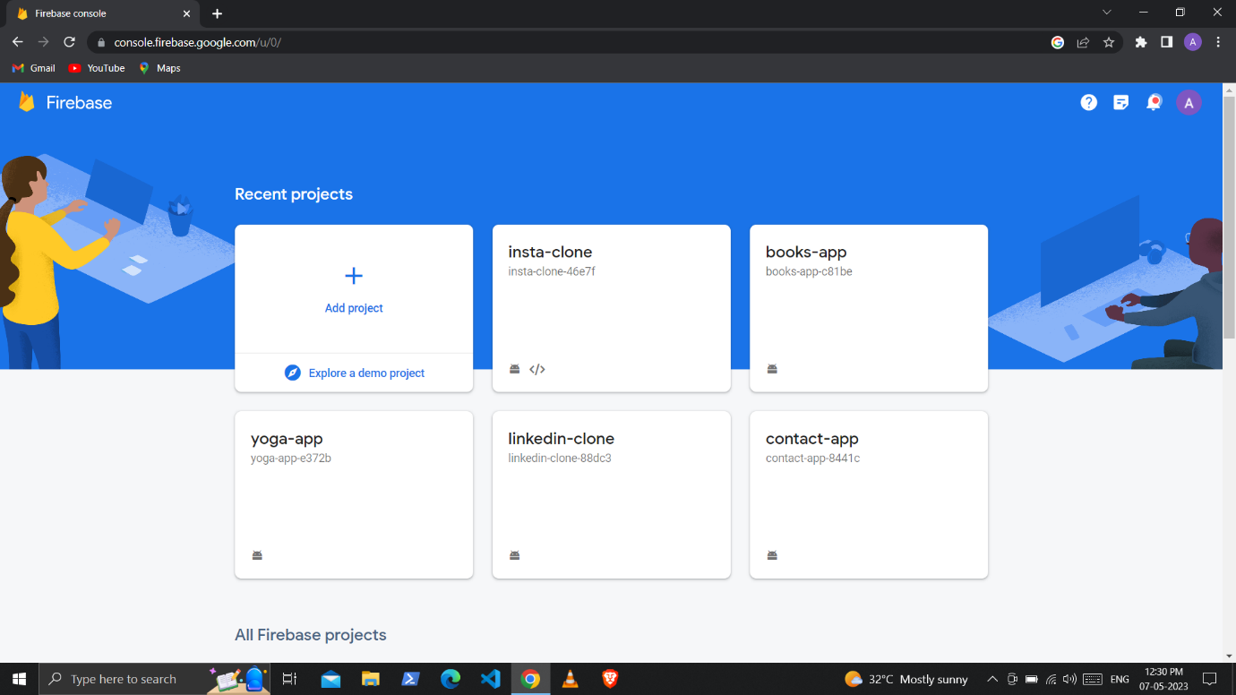

4]Enter you project name and click on continue, In the next screen it will say to enable the analytics but the analytics is not needed to our project so you can disable it and click on next.

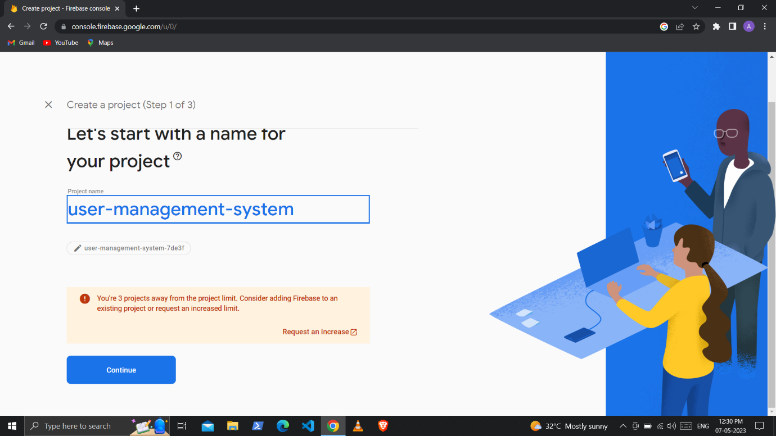

5]After that this type of screen will be appeared there you can see the web icon (</>) simply click on it.

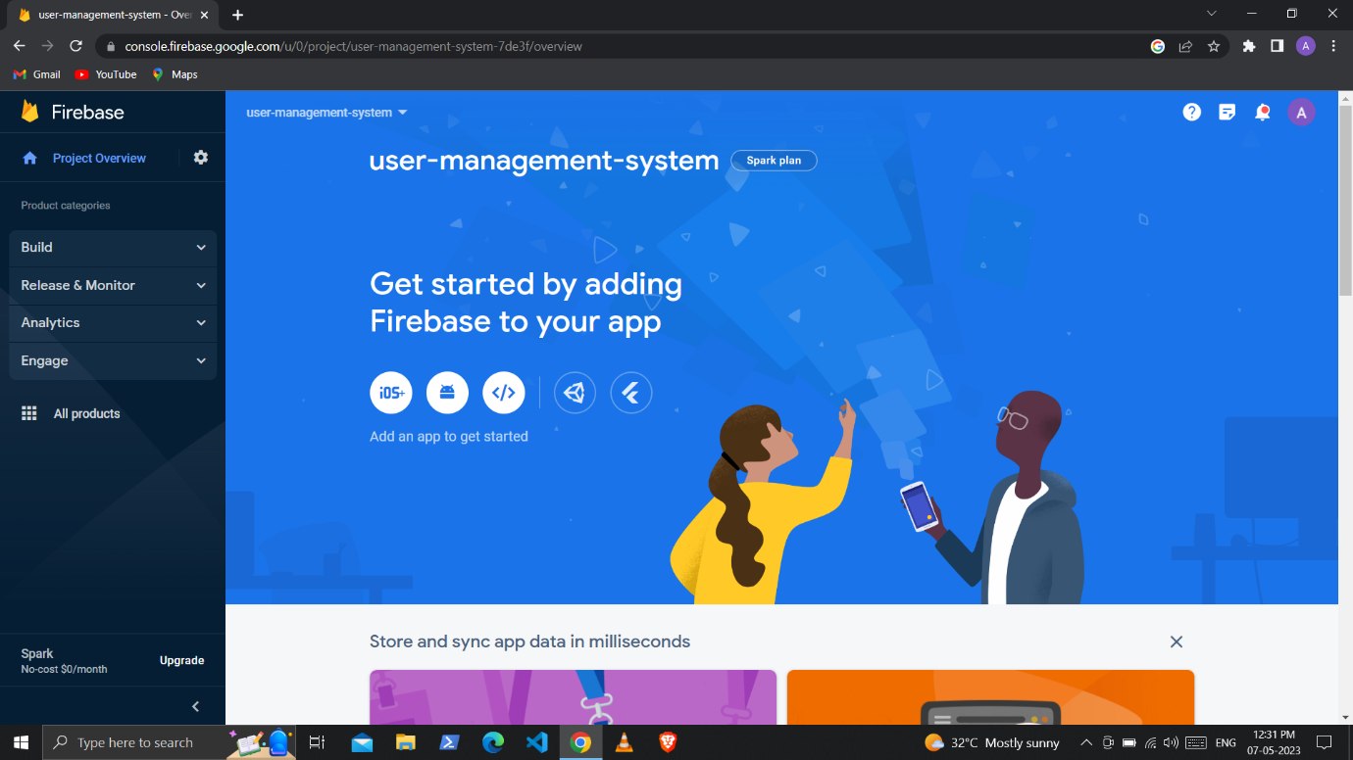

6]Fill the necessary details and click on register app there you will get the credentials and api keys for our application scroll down and click on continue to console.

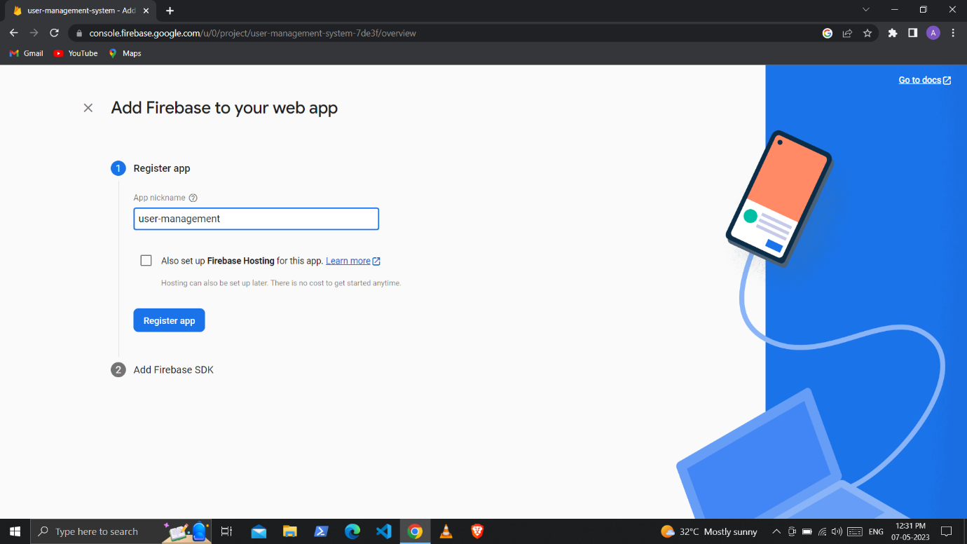

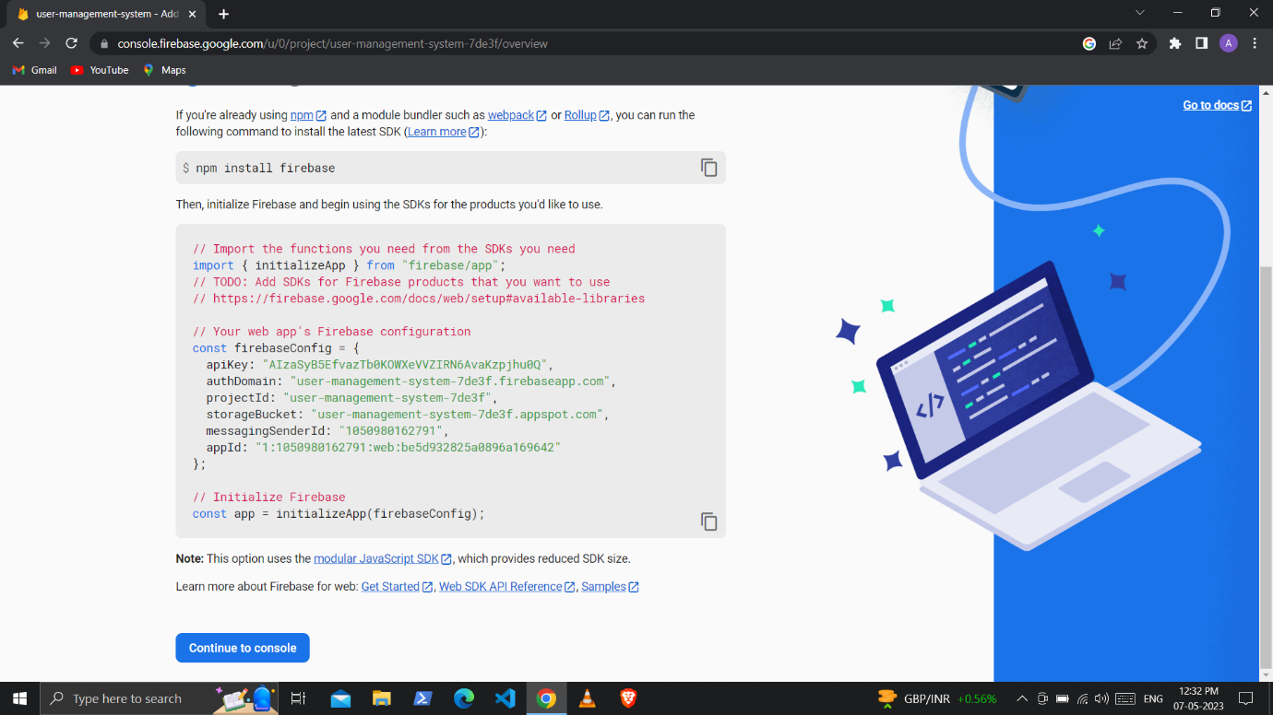

7] On this page click on the build section and click the authentication part. This will add the authentication services to our application

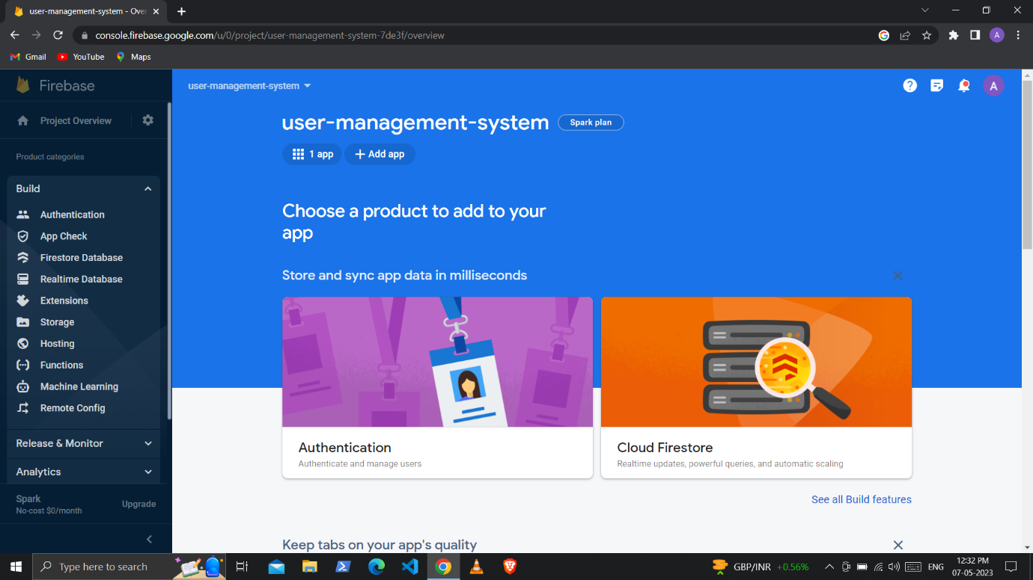

Click on get started.

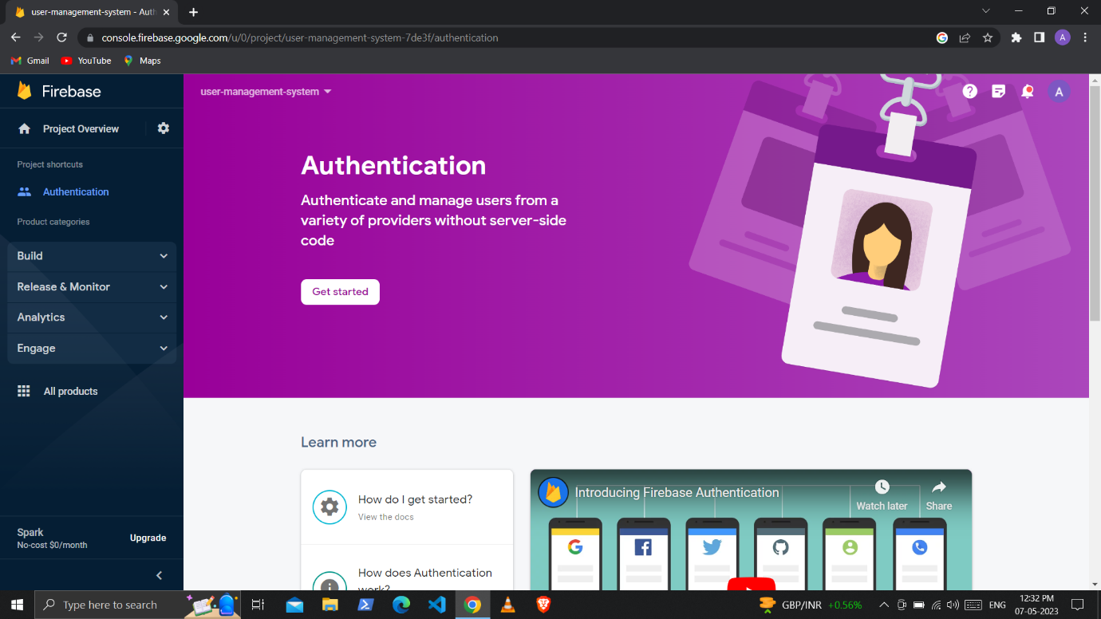

Select email and password

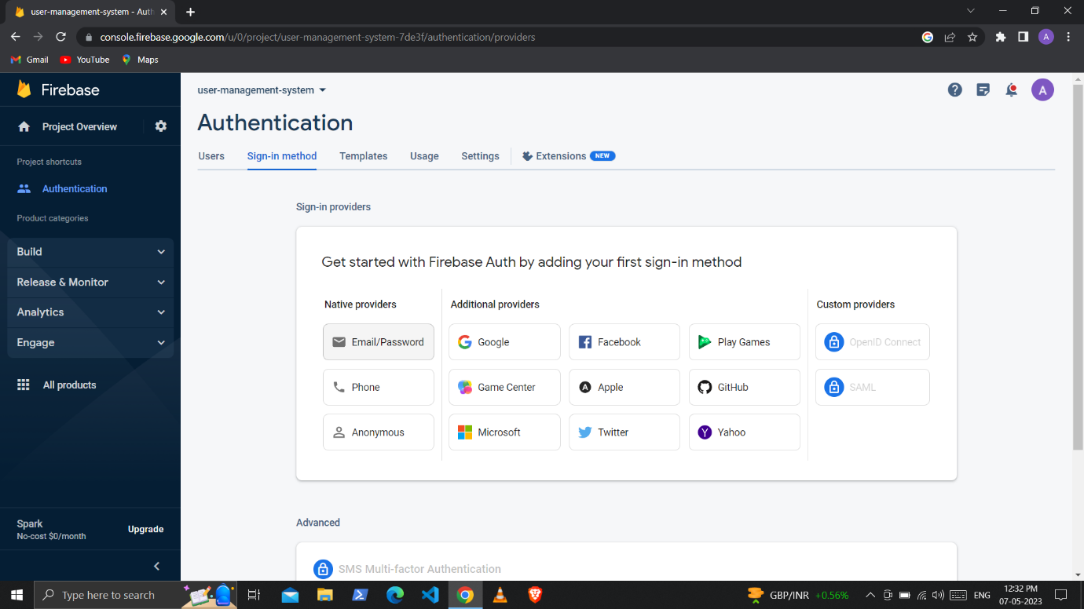

Disable email links and save and your email services will be added

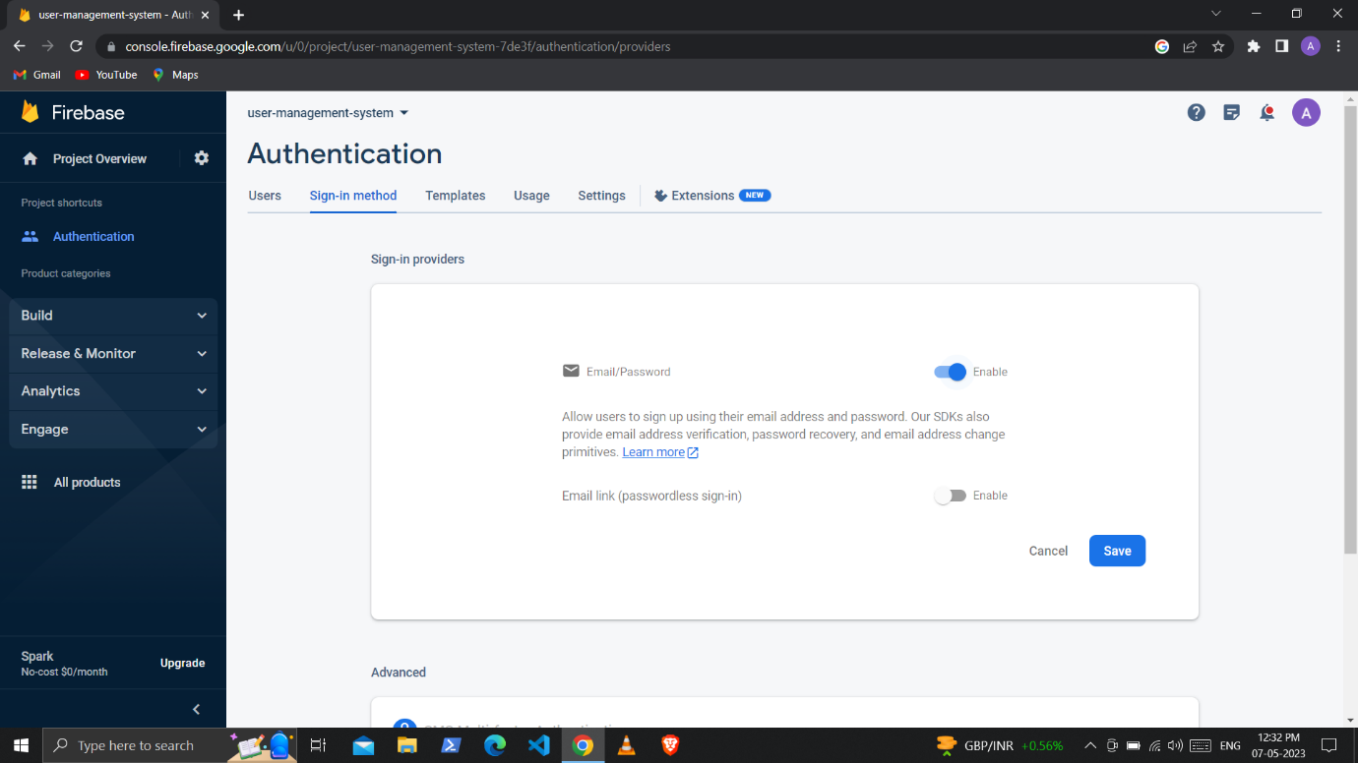

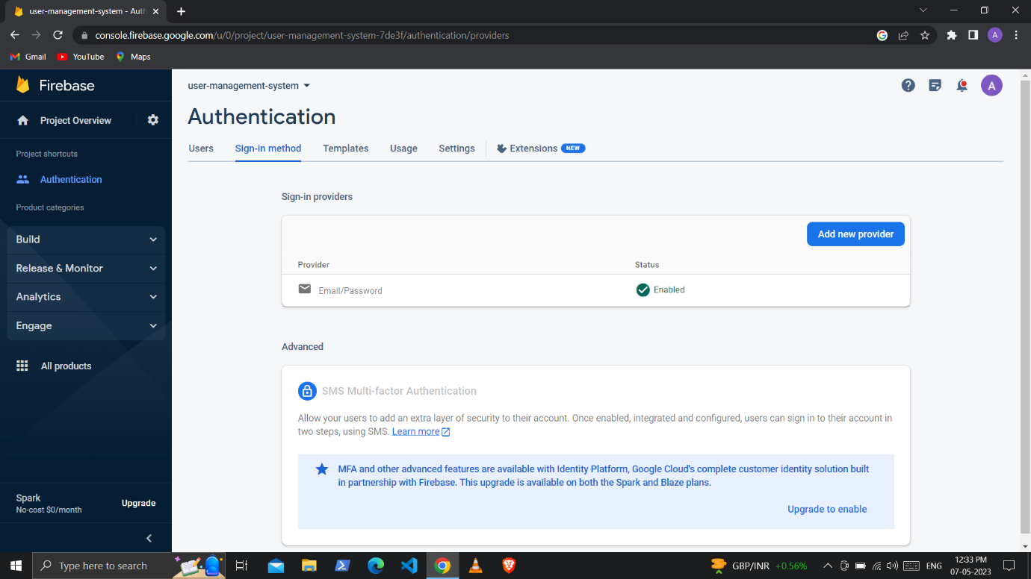

8] Repeat the same procedure click on the build and this time select the real-time Database

And click the ‘Create Database’.

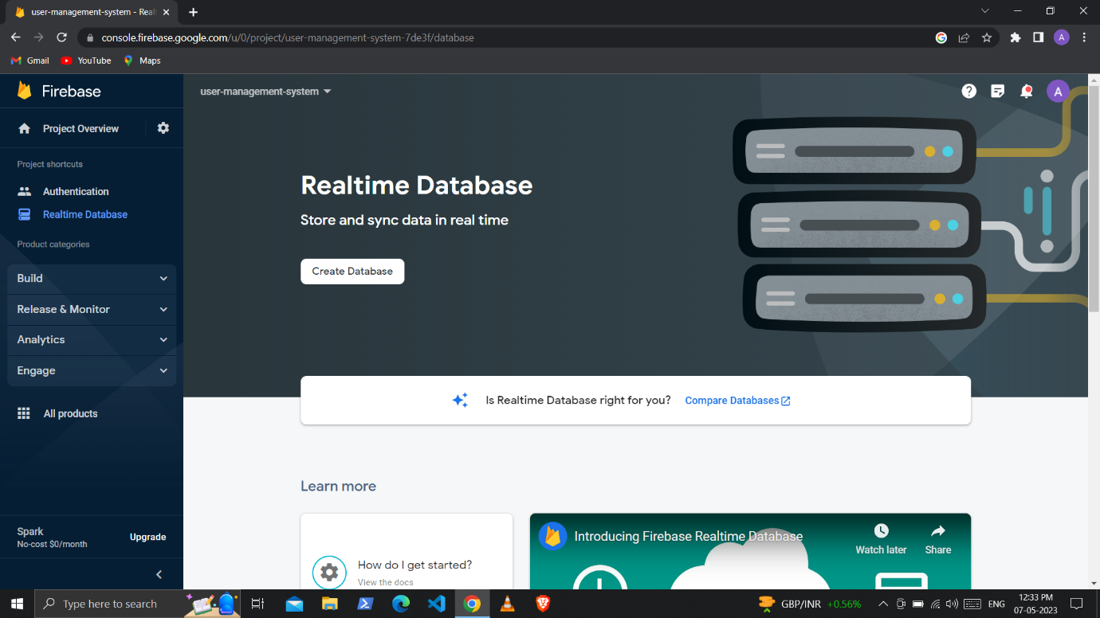

Keep the location of server as it is no need to change

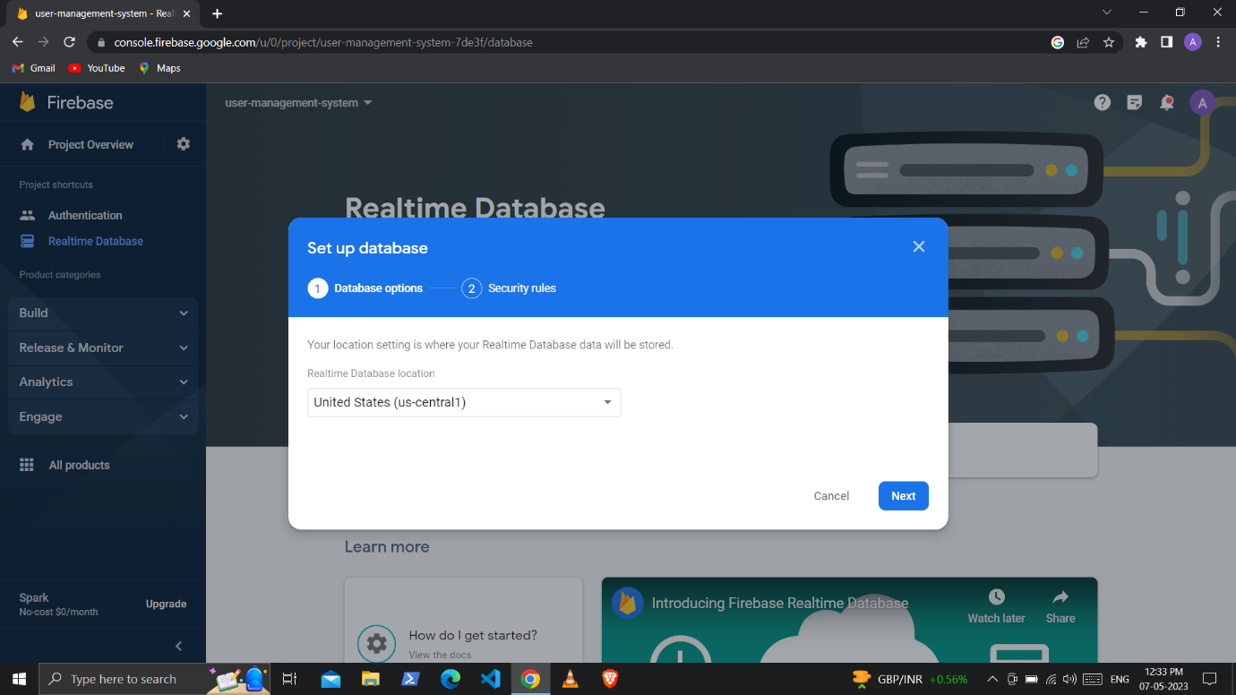

Start the database in test mode and enable

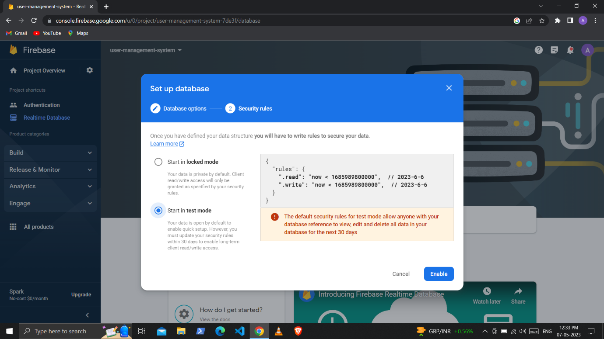

It will look like this

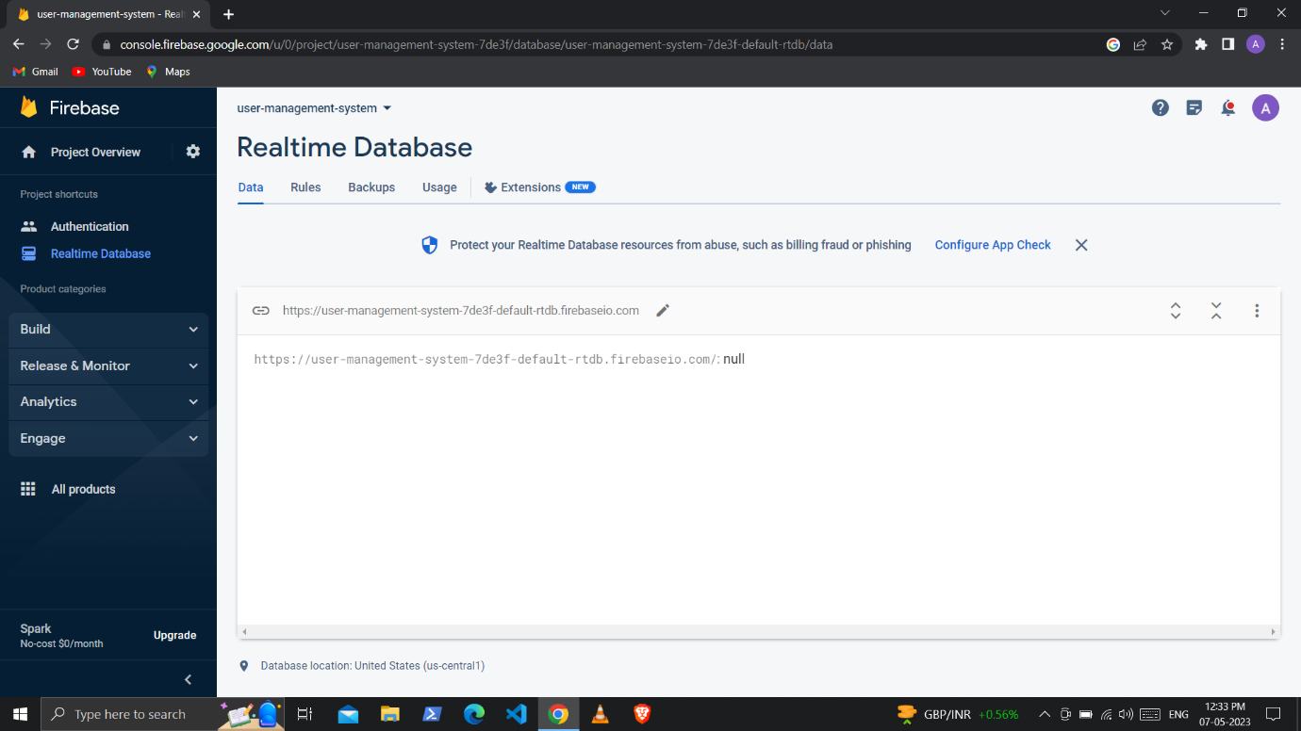

9] On the above screen click on rules section and edit the rules as shown below and then click on publish button

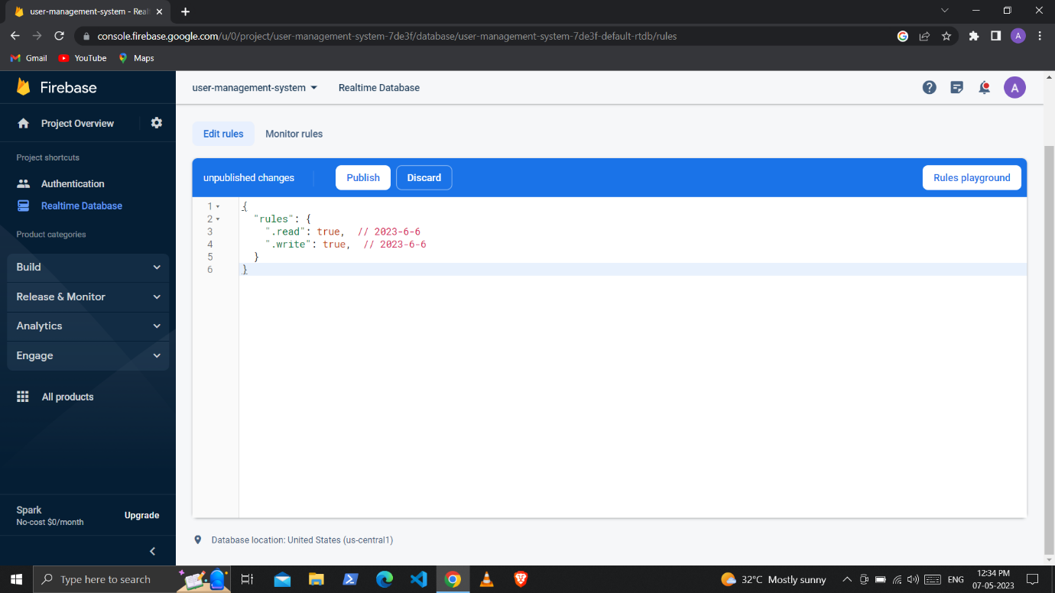

10] If you forgot the credentials of our firebase app then simply go to the Project overview of our project located below the Firebase icon. There click on the web icon and then click on the settings icon scroll down you can see your credentials

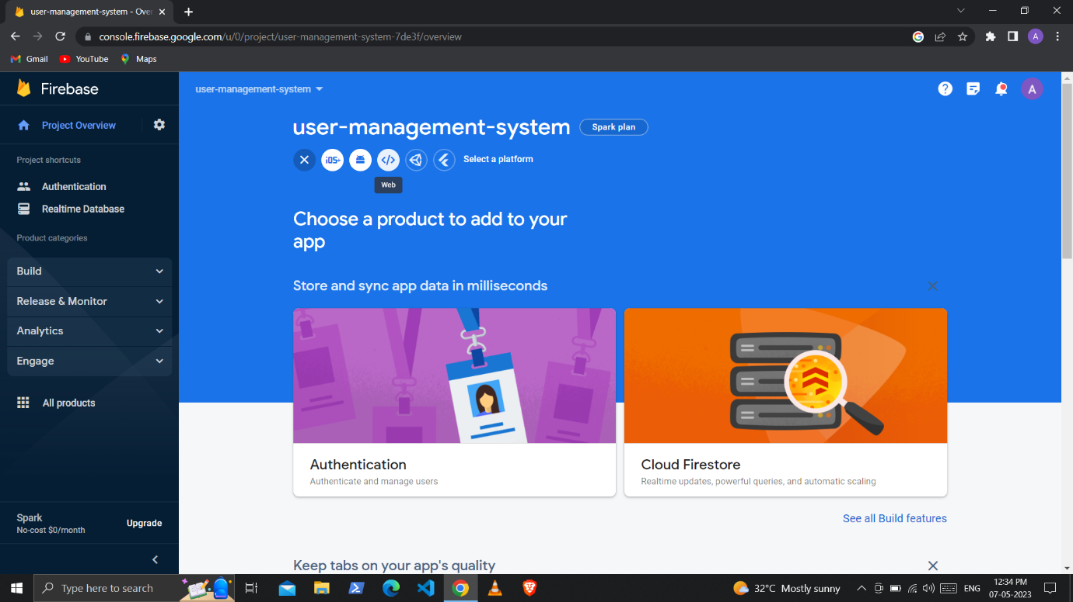

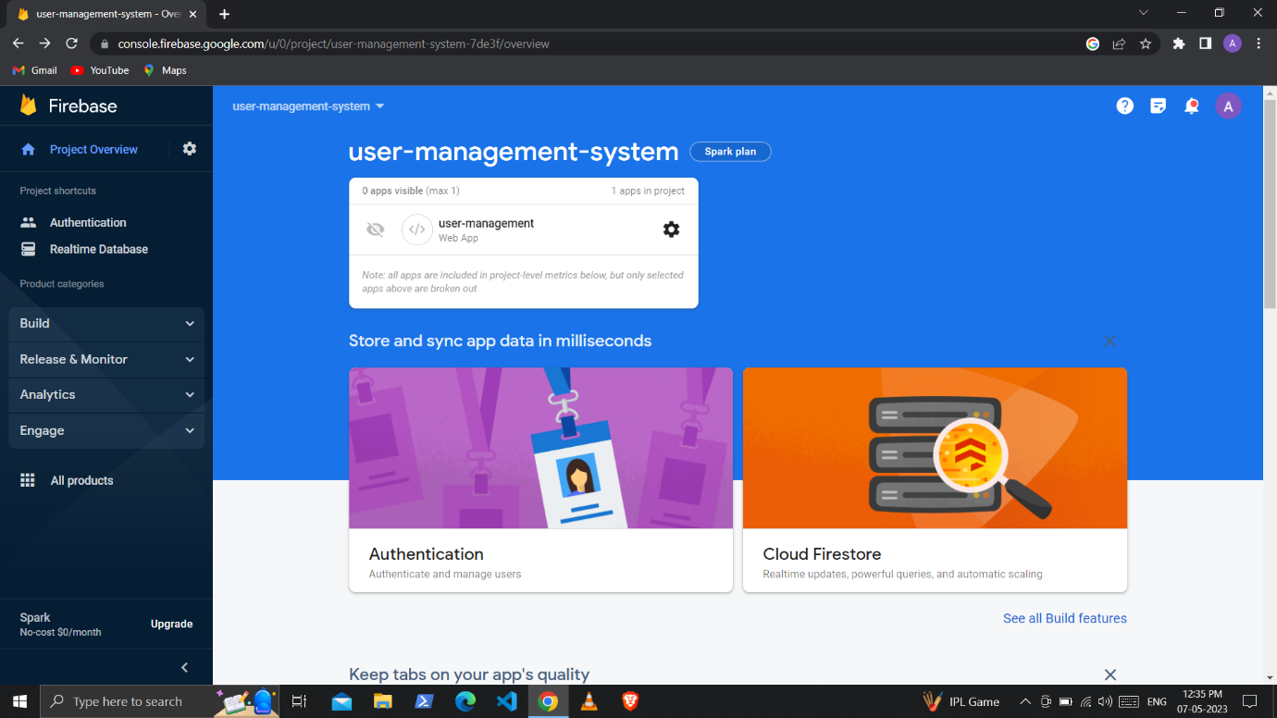

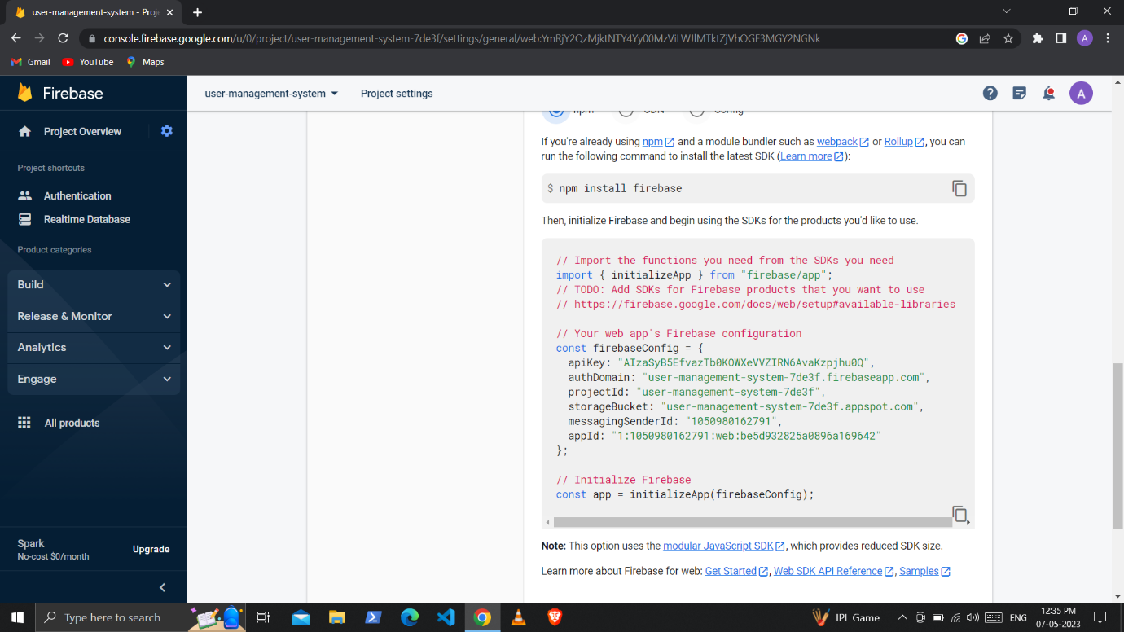

To configure firebase into our application we have to add the sdk of firebase and these above credentials

1] Add the sdk of firebase to the html files above the script tag

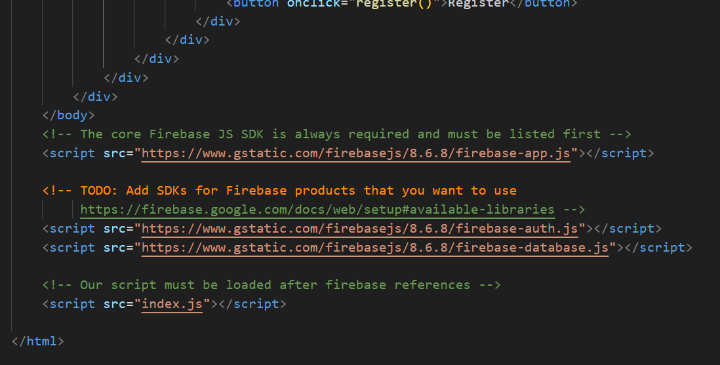

2]Add the credentials to the JavaScript files

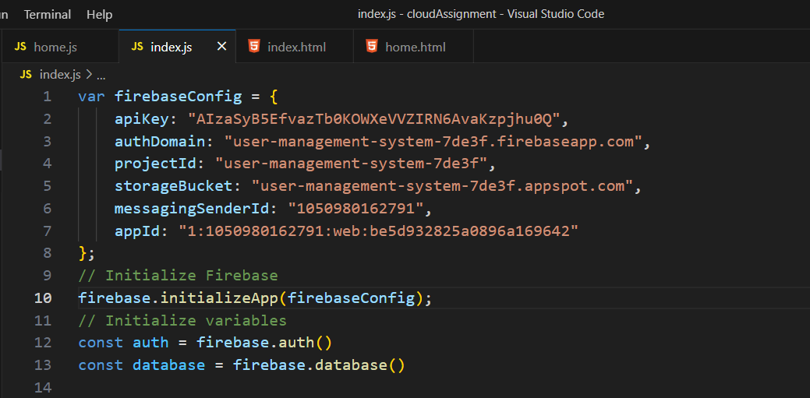

Ifconfig

Touch

Nano

Cat

Scp filname.txt vagrant@ip:/home/vagrant/filename.txt

Ls

Cat

https://github.com/maruti-bangar/